Chapter 13, Solution 43.

Obtain V₁ and V₂ in the ideal transformer circuit of Fig. 13.108.

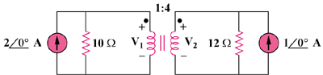

Figure 13.108
For Prob. 13.43

Solution

Transform the two current sources to voltage sources, as shown below.

12 Ω

I₁

I₂
+
–

20 V
10 Ω
+
–

12V

1 : 4

+

v₂

−

+

v₁

−

Using mesh analysis, –20 + 10I₁ + v₁ = 0

20 = v₁ + 10I₁ (1)

12 + 12I₂ – v₂ = 0 or 12 = v₂ – 12I₂ (2)

At the transformer terminal, v₂ = nv₁ = 4v₁ (3)

I₁ = nI₂ = 4I₂ (4)

Substituting (3) and (4) into (1) and (2), we get,

20 = v₁ + 40I₂ (5)

12 = 4v₁ – 12I₂ (6)

Solving (5) and (6) gives v₁ = 4.186 V and v₂ = 4v = 16.744 V

